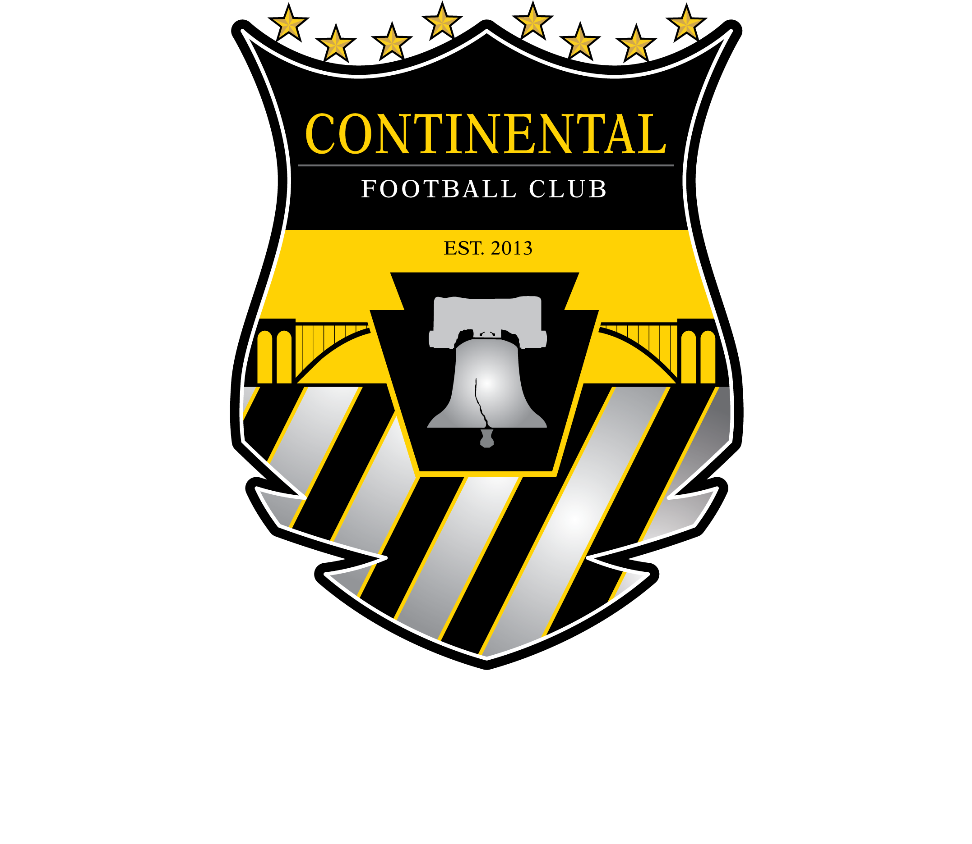**CONTINENTAL FC**

**TRYOUT INFORMATION**

**2018/19 Season**

COST

ECNL $3050

NPL $2350

* Includes all fees other than Uniforms (approx $250 new players) & player travel costs (vary by team)

* Needs based scholarships are avaialble.

Welcome to the 2018/2019 Continental FC Tryouts.  At Continental FC Delco, we want to be the path that positively changes the course of a child’s life and provides an experience kids will remember forever.  Through our **player centric, nationally recognized,** and **community based** approach we will do just that.  At CFC we believe it is all about the player.   Making each individual player the best they want to be by encouraging creativity, awareness, responsibility, and excellence in training. Please see tentative schedule below.

AGE:

U17 (2002)

GENDER

Girls

LOCATION

Conshohocken

TEAMS

ECNL

NPL

**FALL**

**SUMMER**

**Sept - Nov**

* **Team Training Starts Oct 27**
* **Team Training [2 times per week NPL, up to 3 times per week ECNL]**
* **Functional Training**
* **ECNL Goalkeeper Training**
* **1 - 2 Tournaments**

**June - August**

* **Continental FC Summer Camps June and July (camp discounts for CFC Members)**



**WINTER**

**SPRING**

**April - June**

* **Team Training [2 times per week NPL, up to 3 times per week ECNL]**
* **Functional Training**
* **ECNL / NPL Goalkeeper Training**
* **ECNL and NPL League Games**
* **2 - 3 Tournaments**
* **FC DELCO Players Cup**
* **Optional CFC Programs**

**Dec - March**

* **Team Training [2 times per week NPL, up to 3 times per week ECNL]**
* **Functional Training**
* **ECNL / NPL Goalkeeper Training**
* **Break starting December 18th through January 8th**
* **Optional CFC Programs**